SARKIS V. SEUKUNIAN
Address: Glendale, CA | Phone: +1 (818) 345-2372 | Nationality: Lebanese
Email: sako.seukunian@gmail.com
LinkedIn Profile: www.linkedin.com/in/sakoseukunian

PROFILE SUMMARY
Results-driven Software Development Manager with 17+ years of experience in software engineering, integration, and leadership. Proven ability to drive system modernization, CI/CD automation, and align cross-functional teams with enterprise business goals.

PROFESSIONAL EXPERIENCE
Systems & Applications Manager | Aramco Imports, CA -United States
January 2026 – present
Responsibilities:
- Oversee all IT operations, including systems, network infrastructure, security, and business applications.
- Manage IT projects, system integrations, and migrations.
- Administer Active Directory and Microsoft Office 365 environments.
- Collaborate with third-party vendors to manage subscription and license renewals.
- Provide 24/7 on-call IT support.
- Develop annual IT plans, budgets, and technology roadmaps.
- Manage and maintain the ERP system (SAP Business One).
Key Projects & Achievements:
- Developed an internal application that integrates with the ERP system to automatically collect data and deliver real-time alerts via Microsoft Teams to relevant users.
- Created a web-based dashboard displaying sales growth per salesperson and per customer, including an interactive geolocation map allowing sales staff to view customer locations and create orders directly.

Software Development Manager | OMT, Lebanon
April 2021 – January 2026
I joined OMT as a Senior Software Development Specialist in 2021, promoted twice and entrusted with leading OMT’s Software Development Department in March 2024.
Responsibilities:
- Lead and manage the Software Development team, aligning with the Business Analysis, Support, QA and Digital Services teams, while reporting directly to the ICT Director
- Organize and facilitate agile ceremonies: Sprint planning, daily scrums, retrospectives, and sprint reviews.
- Oversee CI/CD practices and ensure smooth deployment pipelines across all back-end applications.
- Manage concurrent enterprise-level projects, integrations, and migrations.
- Ensure team KPIs, developer mentoring, and stakeholder collaboration are continuously optimized.
- Facilitate conflict resolution between developers and cross-functional teams to maintain collaboration and productivity.
- Lead code reviews, project estimation, and resource planning.
- Manage the annual software development department budget, including forecasting, cost tracking, and year-end reporting with a forward-looking financial plan for the upcoming year.
- Deliver annual presentations to the Board of Directors and ICT Director, highlighting key achievements and outlining the strategic vision for the next three years.

Key Projects & Achievements:
- Ongoing successful delivery of Retail and Digital internally developed solutions.
- Directed the creation of a dynamic backend engine which helped the automatic transformation of 70+ services from Retail to the Digital channel.
- Directed the Oracle WebLogic Server migration to the latest supported version.
- Oversaw the Oracle Database Appliance upgrade from X7 to X10 infrastructure.
- Managed the automation of backend and frontend deployments using Jenkins, streamlining DevOps efficiency and reducing downtime.
- Oversaw weekly deployment reviews and proactively prepared detailed maintenance and rollback plans to minimize service disruption and ensure high system availability during production releases.
- Led and oversaw the end-to-end development of the digital backend application, which powered the successful launch of the company’s mobile app in November 2022.
- Managed and ensured high availability of backend applications by creating additional instances and distributing traffic across multiple nodes to optimize performance.
- Directed the JIRA Cloud adoption across the entire ICT division (50 users), leading change management and configuration.
- Led the API integration with Western Union for international money transfers and other payment gateway services.
- Implemented backend APIs to detect SSL/connection errors and API delays by monitoring API database logs and integrated with Microsoft Teams to automatically deliver alerts to the Support team.
- Created a comprehensive transformation execution plan for the modernization of the backend application, outlining the transition from Oracle Service Bus to NestJS.

Senior Analyst/Programmer | First National Bank, Lebanon
Apr 2009 – Apr 2021
Responsibilities:
- Assess new project aspects, perform business and technical requirements study and prepare Gap analysis document
- Develop COBOL & RPG-based in-house programs on the core banking system
- Develop SOAP and REST web services
- Develop reports
- Test the functions and prepare detailed documentation and user’s guide
- Follow up on technical problems and issues with different departments or external companies

Key Projects & Achievements:
- Completed the full automation and integration of the different interfaces with the core banking system by developing web services on IIB system.
- Completed the full automation of the multiple applications on the core banking system:
- Salary domiciliation
- bill payments
- Inward/Outward Cheques management
- Debit/Credit Cards management
- Redesigned all the core banking in-house functions and applications to meet high standards and ensure clean coding
- Redesigned interfaces with third parties which used manual file transfer to fully automate them through Windows Services (Using .NET)

Analyst/Programmer | SAB Méditerranée SAL
Aug 2007 – Mar 2009
- Developed COBOL-based programs on IBM iSeries (AS/400).
- Handled troubleshooting and documentation of banking applications.
TECHNICAL SKILLS
- Programming Languages: COBOL, RPG, C#, VB.Net, Angular, AngularJS, XQuery, OSB, PHP, Java
- Platforms: IIB, IBM API Connect, JIRA, ITSM, Postman, SoapUI, SAP SuccessFactors, Oracle WebLogic Server, Oracle Cloud Infrastructure, Visual Studio, Figma, JIRA
- DevOps: Jenkins, Git
- Databases: Oracle, Microsoft SQL Server, MySQL, DB2
- Systems: AS/400, ODA, IBM Fusion Equation, Microsoft CRM, ERP, Euronet Switch

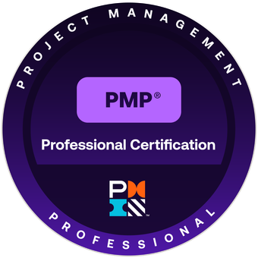
CERTIFICATES
- Project Management Professional (PMP)
Project Management Institute
Issued Dec 2025

- 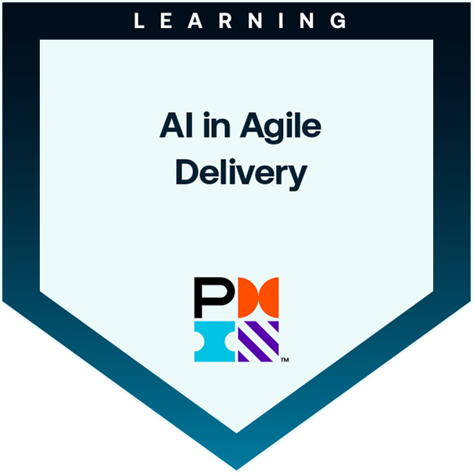AI in Agile Delivery
Project Management Institute
Issued Dec 2025

- 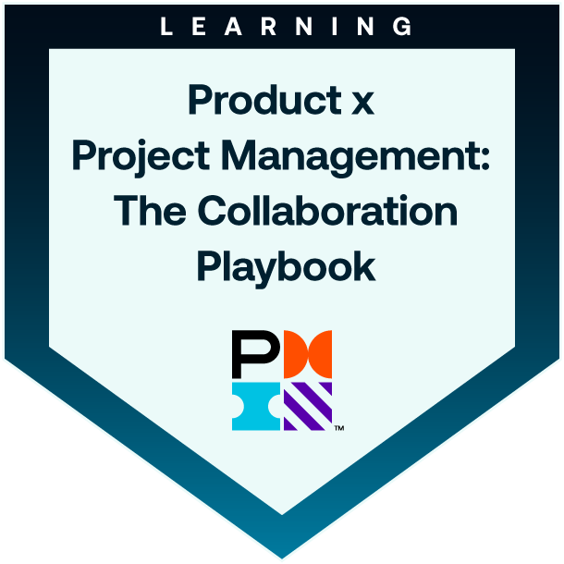Product and Project Collaboration
Project Management Institute
Issued Dec 2025

EDUCATION
- 2003-2007: MA in Computer Science – Lebanese University, Fanar

LANGUAGES
- Arabic – Native
- English – Fluent
- French – Fluent
- Armenian – Fluent

